Rhetorical Analysis
Sophia Linkous
Galef
2/7/24
A Rhetorical Analysis of We Happy Few Propaganda
Imagine a world where everyone is happy. What would that mean? No war? No hunger? No murder? In this hypothetical world, the only way to achieve this is by taking a pill and wearing a mask that forces your face into a smile. This pill would make you not only happy but forget about anything bad that has happened in the past. However, if you stop taking this pill, you will be exiled from society, or even beaten to death. Sounds extreme, right? This idea of everyone being happy and forgetting all the bad things they have done seems all too good to be true. How would everyone agree to such a thing? What was the reason for this forced emotion to create a utopia? In the year 2018, a game made by Compulsion Studios explores this idea through a game titled We Happy Few. Throughout the game, you as the player witness the vast amount of propaganda posters and influential media to support this idea of utopia. The two main forms of propaganda shown are posters and videos. This essay will discuss how the psychology of color affects the consumer, as well as how social influence affects marketing.

Background
We Happy Few is an action-adventure game set in a retro-futuristic version of 1960s England. The game's goal is to survive living in a society where Germany invaded England in 1947 and is currently winning WWII. The citizens of Wellington Wells are given a choice to meet the demands of the Germans or face the destruction of their tanks. The Germans demand that all of the children of Wellington Wells be sent to Germany to be kept as hostages until the end of the war. Every Child under the age of 13 is to board a train to Germany. This caused an uprise of many parents going as far as stealing a registry of names, so no one would notice their child wasn’t on the train, many parents fled Wellington Wells in an attempt to save their children, and some parents hid their children from authorities to keep them safe. Unfortunately, this does not work out for the parents, and they are all publicly hung as punishment, and as a reminder to other parents attempting to disobey the demands. To help the citizens of Wellington Wells forget “The Very Bad Thing” of sending their children away, they commissioned Dr. Verloc of Hayworth Labs to design a drug called Joy. Joy is a capsulated pill that causes people to constantly remain happy, forget about anything negative, and especially forget about the fact that their children have been sent away, returning things to “normal”.
The game is set sometime in the late 1960’s, well into the new society. Throughout the game you play as 3 characters, each with their own story of trying to survive long enough to escape Wellington Wells, Arthur Hastings, Sally Boyle, and Ollie Starkey, each with their own reason for wanting to escape Wellington Wells. Arthur Hastings is the character you start the game as. He works in the archives, printing, and recycling department of Wellington Wells. While playing as Arthur you witness his job of redacting any negative information from the newspaper archives of Wellington Wells. This means any information about the potentially harmful side effects of Joy, as well as the news of the food supply running out, is redacted knowledge. Leaving the general public in the dark and ignorantly happy. Arthur comes across an old newspaper article that makes him remember his brother Percy, with whom he can only associate what happened to him with the haunting sound of a train whistle. This later foreshadows the fact that Percy was sent on the train to Germany. After seeing this article, he decides to stop taking his Joy to remember his brother, what happened to him, and find him. While off his Joy, Arthur shows the player that his surroundings are not as they seem. Arthur is eventually labeled as a “Downer” and is chased out of the city and into the Garden District for not taking his Joy.
As you play through Arthur’s story, you see the world for what it is. People whose bodies reacted negatively to Joy and were kicked out of Wellington Wells and into the Garden District are called Wastrels. Wastrels wear scraps of dress clothes, have unclean appearances, and are struggling to find their next meals. The Wastrels also remember everything from their past, and constantly walk with their head down. Some were crying, some babbling about their hatred for Wellington Wells, and some talking about life before the war when they had their children. This shows the player that Wellington Wells is a giant bubble of ignorance to the outside world. While in the Garden District, Arthur discovers that to escape Wellington Wells, he will have to go back through Wellington Wells Village and travel to the Parade District. Through the Parade District, he can cross Britania Bridge to find Percy.

Artifact No.1
The village is still under the influence of Joy, and many Rhetorical artifacts show that the citizens have no choice but to be influenced. While Arthur journeys through the Village to get to the Parade District, he must cross through many districts of Wellington Wells. The surroundings of the city buildings are constantly plastered with propaganda posters. The two main types of posters you see are posters advertising masks, and Joy (specifically strawberry Joy).
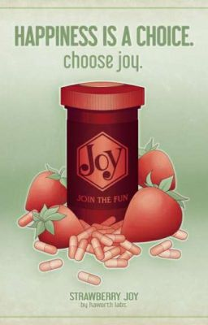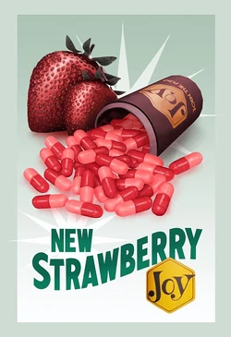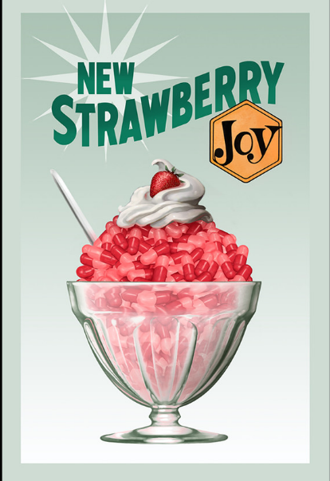
Each of these posters makes Joy seem trustworthy and as harmless as dessert. This is shown through the use of bright colors like pink, red, blue, yellow, and green. All of which catches the viewer’s eye. Joy is revealed to affect the viewer’s vision and perception of color. This is confirmed by the character Sally’s lines. After taking a Joy she will often say “I'd forgotten how ... bright ... Joy is.”. Another line she uses is “Whoo! A bit too bright and shiny, Sally.”. This is also confirmed by the game world being completely transformed and brightened to simulate the experience of Joy. The faded paint on the sidewalk is restored to a vibrant array of colors, the music sounds cheerful, and the peripherals of the screen have a bright pink halo. The sky that was covered in grey clouds is now clear and blue, and the world and everything in it has a pink tint over it. That being said, the bright colors of the propaganda poster were most likely deliberately chosen for this reason.
The color red has the psychological effect of making people hungry. This is stated by Bailey Maybray in the article titled Color Psychology: How To Use it in Marketing and Branding. Maybray writes “Red can also have a physical impact — the color makes people hungry.” The use of large ripe strawberries also reminds the viewer of the taste of a strawberry. Considering the environment of their society, no one has had a strawberry in over 20 years. This would be another reason for a citizen to try Joy, to taste the flavor of a strawberry when they are unable to have them. The color association of red with strawberry flavoring helps the psychological phenomenon of red making people hungry.
The colors green, as well as blue-green Ambre are used as accent colors for text and background colors for the posters. Both colors are complementary to red and contrast with the bright red and pink imagery. Both colors have an association with health and trust. Maybray states “Without exaggeration, green represents life. Reminiscent of grass, trees, and bushes, green brings upon feelings of relaxation, health, prosperity, hope, and freshness.”. He also explains “Blue is the world’s favorite color, with 57% of men and 35% of women ranking it as their top choice. And brands feel the same way: This calming tone is the most popular logo color, with 33% of top brands featuring it in their logo. Blue brings up feelings of security, strength, wisdom, and trust.”. It can be inferred that the posters are meant to be seen as a medication advertisement from a trusted doctor. The color blue is also a well-loved cool color by many and is known to be easy on most eyes.
The logo for Joy is a bright dandelion yellow. This draws the eye right to the product name. Maybray explains “Similar to orange, yellow represents youthfulness and happiness. It’s the color of smiley faces, sunflowers, and rubber ducks. Brands use yellow to tap into optimism, creativity, extroversion, and warmth.”. Yellow was a great choice for highlighting the name Joy, for the reason it is a synonym for happiness, which succeeds in associating the pill with being happy. We can also assume that yellow being associated with flowers aligns with the rise of the flower motif and “flower power” trend that started in the late 60s.
The third picture showing a copious amount of pills in a Sunday glass is associated with the taste of strawberry ice cream. The whipped cream on top with the strawberry resting on it also sells the idea of Joy being appetizing. A common theme between all of the posters is the large abundance of pills. This implies that one bottle will have enough pills to continuously take them, even as instructed on some posters as hourly. The first poster has text at the top and the bottom. The top text reads “Happiness is a choice.” Followed underneath by “Choose Joy.”. This gives a motive for the viewer to be happy because they have an option to be happy without consequence. The tone of the text also seems like it guilt-trips the viewer into taking Joy, posing them with the question “Why wouldn’t you choose to be happy?”. The bottom text reads “Strawberry Joy” and underneath in smaller print reads “by Hayworth Labs.” This demonstrates that Joy is a product of Hayworth Labs and is made within Hayworth Labs, meaning that Dr. Verloc is acting as the voice of the “trusted doctor”.

Artifact No.2
Another rhetorical example would be the videos played on every street corner by Joy Detectors. Joy Detectors are one of the obstacles the player faces within the game. They have a sensor and alarm system that will alert the citizens around you that you are not taking your Joy. This leads the citizens and police officers known as “Bobbies” to chase you and cause harm. During Arthur’s time in the Village, every street corner has a TV that serves as a joy detector, while simultaneously playing episodes of the Wellington Wells media spokesperson “Uncle Jack”.
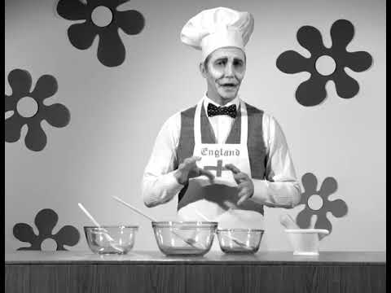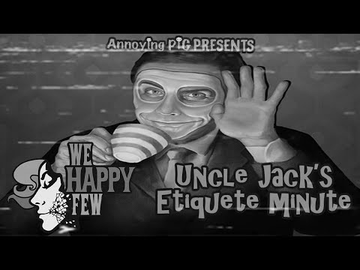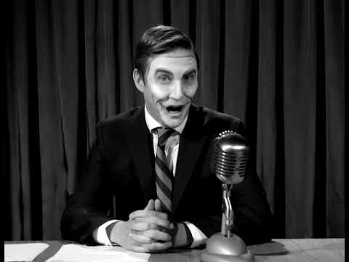
Uncle Jack serves as the voice of influence for the city. He constantly reminds the viewer to take their Joy, play Simon Says every day at 3 o’clock, and conserve food. He also hosts the etiquette video for people who are trying to get back into Wellington Wells. The videos show that he is charming and likes to crack jokes for the audience. He wears a mask to set an example for the rest of the citizens. Jack is so popular within this society to the point where he has a cult following called “The Uncle Jack Fan Club” or “Jack-O Bean Club”.
The first video is Jack explaining how Lichens are edible and citizens should use them for recipes to conserve the amount of food within the Village. The citizens are more likely to listen to him because they all feel like they have a close relationship with him, considering they watch him every day, and he hosts Simon Says every day at 3 pm. Because of Simon Says, we can assume that the Village already is used to following exactly what Jack says is good for them or what they should do for the sake of Wellington Wells. The use of the chef’s hat and apron is to show the audience that he is cooking or has cooked before. What is interesting is the fact that we never actually see Jack cook, just talk about the ways Lichens can be eaten and the history of Lichens.
The second video of Jack is the etiquette video that Arthur watches as he goes through “rehabilitation” to re-enter Hamlyn Village (a part of Wellington Wells). In this video, Jack is his normal charming self, and even cracks a joke saying “Clothes make the man, eh? Indeed, naked people have no influence at all in society!”. Not only is this reminding the player to make sure their character has an outfit equipped, but it also shows that Jack has that crude edge factor that society finds “cheeky”. Jack then goes on to mention that if people get suspicious that you have forgotten to take your Joy to say “Who cares?” And pop another. This shows that he influences people to take Joy at any time they are being stared at or trying to avoid conflict.
In the third video, Jack mentions “Today we will all gather around the Telly for a rousing game of Simon Says. Well, I won’t be gathering around the Telly. I’ll be in the Telly! Just like every day I’ll be playing it with you!”. This shows his charm and humor, he then goes on to say “And there will be cake and prizes for all winners. And everyone’s a winner! And everyone will be there! So don’t miss it or you’re a rotten egg! Ha ha!”. Jack uses the pressure of being a “rotten egg” which can be seen as a Downer, or someone who chooses not to have fun to influence the audience to play Simon Says. He presses even further by saying “But seriously, unless you have an awfully good reason, such as two broken legs, do be a sport at 3 o’clock won’t you? We love your company.”. This almost seems like a threat to the viewer. The use of “We” at the end also suggests that he is speaking for the collective hive-mind of the Village.
Conclusion
Both the posters and the videos influence society to take Joy frequently. Jack in videos uses pressure from society and oddly threatening phrases. Whereas the posters use bright colors and bold statements to affect the consumer, working in favor of Joy’s side effects. Both achieve their purpose of influencing the people through societal pressure and psychological tactics, as well as the position of power both messages are coming from. Joy is the result of power from Hayworth Labs, and Jack’s influence is the result of power by people pleasing, fear tactics, and brainwashing. Ultimately leading to controlling society through the emotions they should be avoiding.
Sources:
“Annoying Pig Presents: We Happy Few - Uncle Jack’s Etiquette Minute.” YouTube, 9 May 2022, youtu.be/ojDQSRC20mc.
Artstation - Explore, www.artstation.com/artwork/. Accessed 5 Feb. 2024.
“Color Psychology Used in Marketing: An Overview.” USC MAPP Online, appliedpsychologydegree.usc.edu/blog/color-psychology-used-in-marketing-an-overview. Accessed 4 Feb. 2024.
Fabbri, Megan. “Opinion: ‘We Happy Few’ Shows the Dangers of Ignorance in Several Forms...” The Beat, 15 Aug. 2018, www.comicsbeat.com/opinion-we-happy-few-shows-the-dangers-of-ignorance-in-several-forms/.
Maybray, Bailey. “Color Psychology: How to Use It in Marketing and Branding.” The Hustle, HubSpot, 11 July 2023, blog.hubspot.com/the-hustle/psychology-of-color#:~:text=Color%20psychology%20has%20long%20been,trust%2C%20serenity%2C%20or%20authority%3F.
says:, A WordPress Commenter. “The Jaded ‘Hero’: An Analysis of Sacrifice in ‘We Happy Few’ / Sabrina Ng.” Digital Patmos Vol 2 No 2, digitalpatmos.com/vol2issue2/wehappyfew/. Accessed 4 Feb. 2024.
“That Tastes Amazing, What Is It - Lichens: Uncle Jack: We Happy Few.” YouTube, 1 Nov. 2018, youtu.be/vxiMlokLI7I.
“Wakey Wakey - WAKEY #1 | Uncle Jack | We Happy Few.” YouTube, YouTube, 1 Nov. 2018, www.youtube.com/watch?v=GPFCzlbjhaY.
“We Happy Few: The Story Explained.” YouTube, 14 July 2022, youtu.be/MzGNFAsaQmE?si=LjzsEv5teX9nOg32.

